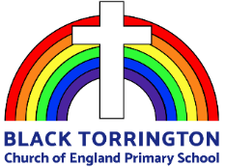
Parent Curriculum Information Autumn Term 2022
Maths  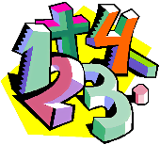  Our first topic is place value and will enable the children to secure their understanding of the fundamental way in which our number system is organised. The children will work at a level appropriate to their mathematical development, ranging from working with tens and ones up to 7-digit numbers. The children will then apply this understanding in the next topic, which involves exploring the four operations. Beginning with addition and subtraction, then progressing to multiplication and division as appropriate, the children will practise mental methods and written calculation strategies. |  | English  To link with our topic Prehistoric Britain, the children will read the book ’The Stone Age Boy’ by Satoshi Kitamura. They will use their growing knowledge of life in Stone Age Britain to help to write a story following a similar structure to the model text.  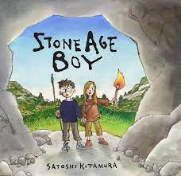  Our other inspirational text this term is ’Fantastically Great Women Who Changed the World’ by Kate Pankhurst. Based on the women the children read about, they will select a woman to research in more detail and create a biographical page about their chosen woman that could appear in the book. In order to be authentic to the text, they will explore the novel layout, illustrations and use speech bubbles.
Science  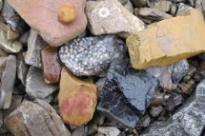  Our topic for the first half term is ‘Mixing and Making in KS1 and ‘Separating Mixtures’ in KS2. Both topics help to develop children’s understanding of solids, liquids and gases. The children will observe and conduct practical ways to separate mixtures, including techniques such as evaporating and filtering.  In our second topic, we will explore rocks and how they are formed, including Earth’s structure. | History  Prehistoric Britain is our topic this term. The children will learn about life in the Paleolithic, Mesolithic and Neolithic eras, including animals of the time that are now extinct and human development. They will compare and contrast early human existence with life today.  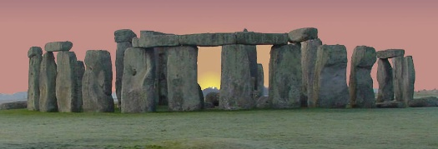 |  |  | Geography  In Geography, our focus will be Villages, Towns and Cities. The children will explore the key features of different types of settlements and how they are different to live in. They will investigate what affects where people live. Hopefully, we will visit Exeter to identify city features we have learned about.
PSHE  Our themes this term are ‘Me and My Responsibilities’ and ‘Valuing Difference’. Both of these topics will support our reflections on Black History Month. The children will have the opportunity to explore their own and others’ feelings, behaviour and relationships. | Art  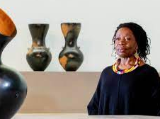  In art, the children will explore the work of ceramicist Magdalene Odundo. They will use her work as inspiration to design and create their own pieces. |  |  | RE  In RE this term we are looking at Christian ideas about creation including what the Christian creation story teaches us about how God wants Christians to live.
Music  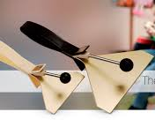  Continuing with our new music programme, we will be focusing on singing. The children will learn how to use their voices creatively when singing individually and together as a class. They will learn new musical terminology and concepts, including pitch, tempo and dynamics. Additionally, the children are continuing to learn to play the handbells with volunteers from the local church. Watch out for upcoming performances! |  |  | Computing  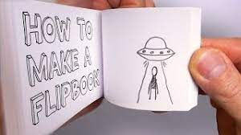  The focus for this term is to how to create an animation. The children will begin by looking at how flick books create the effect of a moving image using still pictures. They will then apply this knowledge to use software to produce their own animation using appropriate software.

Supporting your child’s learning at home
Class Dojo  Please make sure you check our class dojo page regularly. We will use it to update you with what is happening in school.  Look out for photos of what we are doing as well as dojo points the children receive. | Reading  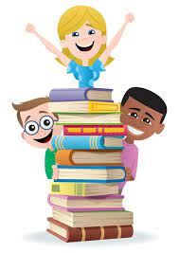  Reading at home is a vital part of children’s development at all ages in primary school. The more opportunities your child has to practise reading, the more their skills, fluency and confidence will develop. They will expand their vocabulary and awareness of sentence structure and punctuation, which in turn impacts their writing. Children are expected to read at home at least three times a week, but ideally every day for at least 10 minutes. As they get older, they should aim to work on their reading stamina so by Year 5 and 6 they should read for 20 – 30 minutes. Please record your child’s home reading in their reading record and ensure it is in school every day.
Homework  The children will be set a weekly homework task. This will usually have a maths or English focus but may also be related to our science or topic work.  In addition to set homework, it would be beneficial if you could help your child to practise key skills such as times tables and telling the time at home. | PE  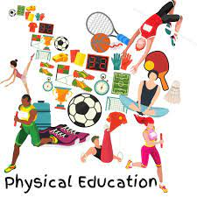  The children have two PE lessons per week: one on Monday and one on Friday. On Mondays, we travel to Bradford to share our PE lesson with the children there, which is helping the children to develop new friendships. PE also continues to be on Fridays with Mr. Pugh. Please ensure that they have their full school PE kit on Mondays and Fridays, but preferably every day. Additionally, we encourage the children to be active outside of school too and love to hear the children talk about the physical activity they do at home.

