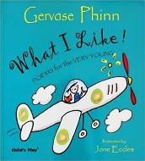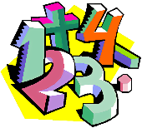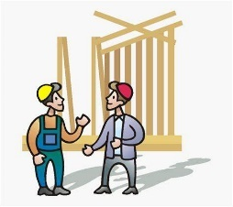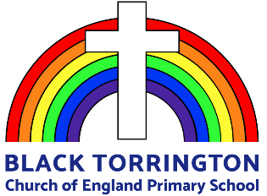

**Topic title and aim**

**London**

We will be learning all about our Capital City, including its origin, geographical properties and its history. The children will be exploring who created London, what London is and the different landmarks and their significance.

**Maths**

We will all be exploring addition and subtraction at different levels and learning to work with numbers up to 50.

Height, length, weight and volume will be explored and the children will be working together and independently to solve different problems.

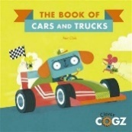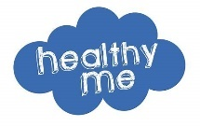

**English**

**Poetry**

The children will be learning about poetry and discovering different ways of expressing their thoughts and feelings. We will be exploring the different types of poetry and continuing to develop our sentence structure and punctuation.

**PSHE**

**Keeping myself safe**

The children will be learning how to keep their bodies healthy. Through the importance of healthy eating, sleeping and washing, exercising

**Science**

**Sounds**

This term we will be learning about sound and exploring how we hear. We will be creating different sounds and investigating the ear and how to take care of it.

**Building Things**

We will be exploring different materials and experimenting which are the best to build a wall with. The children will be discovering which are heavy or light, waterproof and which withstand strong winds.



**RE**

Jewish People and how they live

School Values through Bible stories

Godly Play



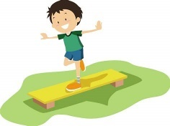

**Music**

Using our voices creatively

Listening carefully

Rhythm and Pulse



**PE**

Real PE

Dynamic balance and Static balance

Order instructions, movements and skills.

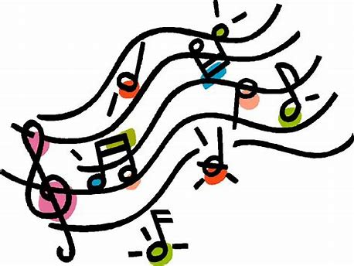

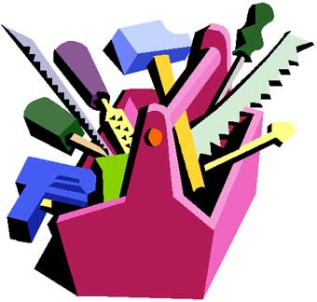

**Art and Design Technology**

The children will be exploring mark making using charcoal

We will also be building structures to link with our science topic of building things. We will be investigating different materials to create a variety of structures.



**History**

We are learning about the origins of London and who created the city. The children will explore the events that took place dating back to 43 CE to the present day.

**Geography**

We are learning about London and its geographical properties. The children will be exploring the difference in scale between villages, towns and cities. We will be looking at London’s place in the UK and its significance to our country.

**Computing**

Moving Robots

The children will be learning how to move robots through inputting different directions



**Supporting your child’s learning at home**

**Homework**

We will be setting the children homework each week. These pieces of homework will cover maths, reading and handwriting with the occasional topic-based piece of work. I will keep you updated on what is set on Class Dojo so please check in regularly to stay updated.

**Reading**

Reading at home is a vital part of a child’s learning and development. The more opportunities your child has to practice blending and reading words the quicker their skills and confidence will develop.

Children in class one are expected to read at home at least 3 times a week, but ideally every day. At this age ‘little and often’ is the best approach to any learning.

Please record any reading in your child’s reading diary as these reads will count towards their reading certificates.

It is important that children also read and share stories for pleasure, listening to and reading a range of books that they enjoy to build a love of reading.

A reminder that children should have their reading records in their bags everyday – we have made the children reading pouches that live in their bags to make this easier.

**PE**

Class One have PE on a Tuesday with Miss Squire and a Friday with Mr Pugh so please make sure that their PE kits are in school on these days, preferably every day.

**Class Dojo**

Please make sure you check in regularly to our class dojo page. I will use it to update you with what is going on in school as well as any reminders.

**Maths**

Counting is a vital part of learning how to be a mathematician and so counting forwards and backwards with your children will support their development. Counting in 2s and 5s is just as important as counting in 1s and this can be done through speaking or singing – there are lots of lovely counting songs available online for you to use if you would like them!