Curriculum Guarantee-40 things to do before you leave Bradford Primary School!
How many can you tick off the list?
Use public transport | Learn outdoors | Know different types of birds and trees | Experience yoga, meditation, mindfulness | Learn to swim
Learn to cook with basic skills  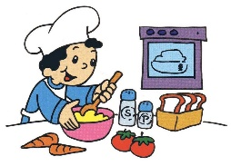 | Understand money and financial management | Have a knowledge of local history and geography | Know how to keep mentally healthy | Know what democracy means
Go to the theatre | Experience drama | Have a basic first aid knowledge | Build a den | Climb
Do something that needs courage and determination | See a tadpole or butterfly grow  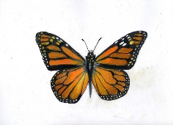 | Go fossil hunting | Learn to sew | Develop a mechanism to make something work
Learn about jobs/careers | Play an instrument | Pond dip and go rock pooling at the beach  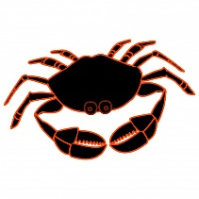 | Dress up | Have a picnic

Roll down a hill | Learn how to ride a bike safely | Go barefoot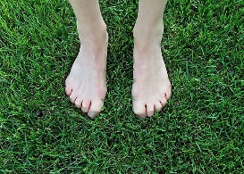 | Find your way with a map | Send a letter
Go on a scavenger/bug hunt | Know how to play board games  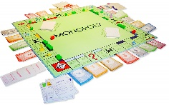 | Use a magnifying glass/binoculars | Make a daisy chain | Read a classic book
Talk to another generation  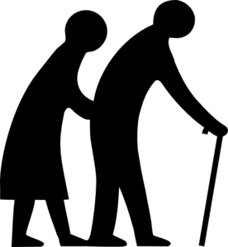 | Visit a farm | Have a conversation in a different language | Make bug houses and bird boxes | Sing in a choir

